Computer Science
COURSE CONTENT:
Unit 1 – Computer Systems | Unit 2 – Computational thinking, algorithms and programming
- System Architecture  - Memory and Storage  - Computer networks, connections and protocols  - Network security  - System software  - Ethical, legal, cultural and environmental impacts of digital technology | 2.1 Algorithms  2.2 Programming fundamentals  2.3 Producing robust programs  2.4 Boolean logic  2.5 Programming languages and Integrated Development Environments

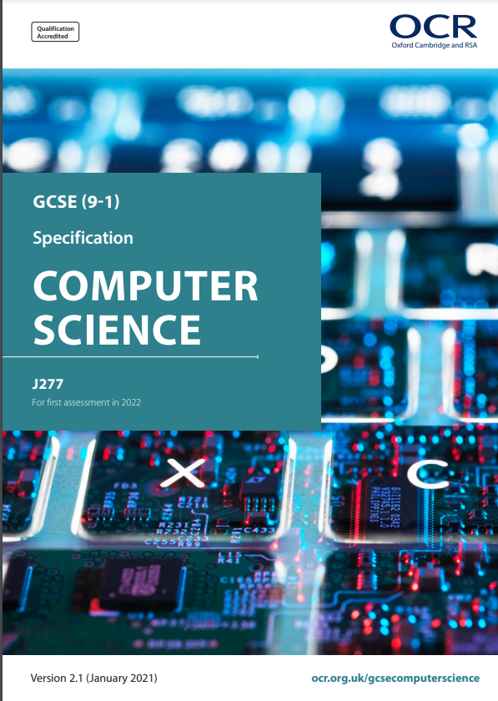

Exam Board
Specification

OCR
GCSE Computer Science (9-1) J277

Assessment Details
In class formative assessments take place at the end of each topic, with summative assessments at the end of each term. Pupils are expected to practice their programming skills on a fortnightly basis by completing programming challenges for homework to develop their algorithmic thinking skills.
There is also an expectation that students complete a 20 hour programming project over the length of the course and although this is not formally assessed, it is key to success in the final exams.
Final Examinations
2 exams to be taken in May/June 2026
Each exam is out of 80 marks and accounts for 50% of the grade
Pupils are not currently assessed on their programming skills, but are assessed on Computational Thinking skills through their ability to produce algorithms that solve specific problems.
The final grade is awarded based on the result of both marks combined
Skills/Aptitudes Required for Success
Problem solving
Team work
Independent thinking
Good communication
Pupils who enjoy maths and science will succeed in this subject

Staff Contact for Further Information
Mrs McGloin, Head of Technology

