GCSE Food Preparation and Nutrition
COURSE CONTENT:
This GCSE equips learners with the knowledge, understanding and skills required to cook and apply the principles of food science, nutrition and healthy eating. It encourages learners to cook, enables them to make informed decisions about food and nutrition and allows them to acquire knowledge in order to be able to feed themselves and others affordably and nutritiously, now and later in life. Areas of Content that are looked at are:
1. Food commodities 2. Principles of nutrition 3. Diet and good health
4. The science of food 5. Where food comes from 6. Cooking and food preparation

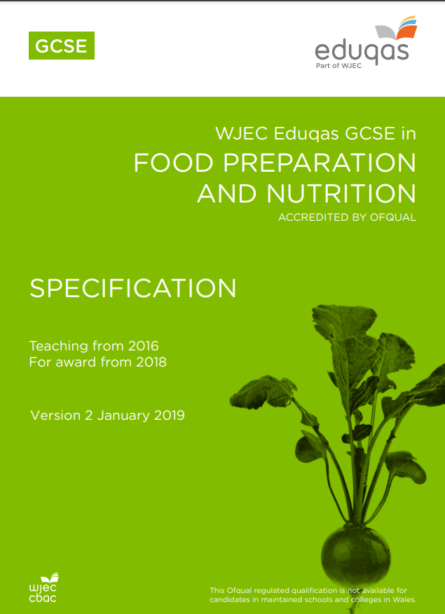

Exam Board
Specification
Eduqas Level 1/Level 2 GCSE (9-1) in Food Preparation and Nutrition - 601/8093/6
Eduqas
Assessment Details
Component 1: Principles of Food Preparation and Nutrition Written examination: 1 hour 45 minutes. This forms 50% of qualification.
Component 2: Food Preparation and Nutrition in Action non-examination assessment: internally assessed, externally moderated. This forms 50% of the GCSE qualification. As part of component 2 there are 2 assessments.
Final Examinations
Assessment 1: The Food Investigation Assessment which is a scientific food investigation that will assess the learner's knowledge, skills and understanding in relation to scientific principles in the preparation and cooking of food. Assessment 1 is for 8 hours where students will produce a written report, which is 2,000 words.
Assessment 2: The Food Preparation Assessment where the students will prepare, cook and present three food dishes during a three hour practical, which assesses the learner’s knowledge, skills and understanding in relation to the planning, preparation, cooking and presentation of food. Assessment 2 is for 12 hours where students will produce a written report, which is 30 sides of A4.
Skills/Aptitudes Required for Success
Organisation skills
Problem solving
Creativity
Staff Contact for Further Information
Mrs. C Bowden, Teacher of Food Preparation and Nutrition

