Cambridge National: Health and Social Care
COURSE CONTENT:
The Cambridge National in Health and Social Care will inspire and equip students with transferable skills that are relevant to the Health and Social Care sector and more widely. It covers the rights of individuals, person-centred values of care, how to protect individuals in various care settings and learn about the impact of life events.
To work in a health or social care setting, it is essential to understand the rights of individuals, person-centred values and how they can be applied. This qualification will help you to develop this knowledge and to understand the importance of effective communication skills when working in these settings. You will also develop the skills needed to ensure a safe and hygienic environment for those in care.

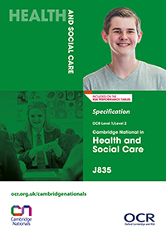

Exam Board
Specification
OCR Cambridge Nationals
Health and Social Care Level ½ - J835
OCR
Assessment Details
Component 1: Written coursework. R033 Supporting individuals through life events, non-examination assessment: internally assessed, externally moderated – 60 marks. This forms 30% of the final qualification.
Component 2: Written coursework. R034 Creative and therapeutic activities, non-examination assessment: internally assessed, externally moderated – 60 marks. This forms 30% of the final qualification.
Final Examinations

Written exam: 40% of the final qualification. R032: Principles of care in health and social care settings, 70 marks, 1hour 15 minutes.
Skills/Aptitudes Required for Success
Organisation skills
Problem solving
Practical creativity
Staff Contact for Further Information
Mrs. C Bowden, Teacher of Health and Social Care

