GCSE Business
COURSE CONTENT:
The course consists of two themes of study; Theme 1 – Investigating small business and Theme 2 – Building a business. In theme 1 students will explore the skills required to be an entrepreneur, how business opportunities come about and how to make the business effective. In theme 2 students examine the ways to make a business grow and the impact of business decisions.

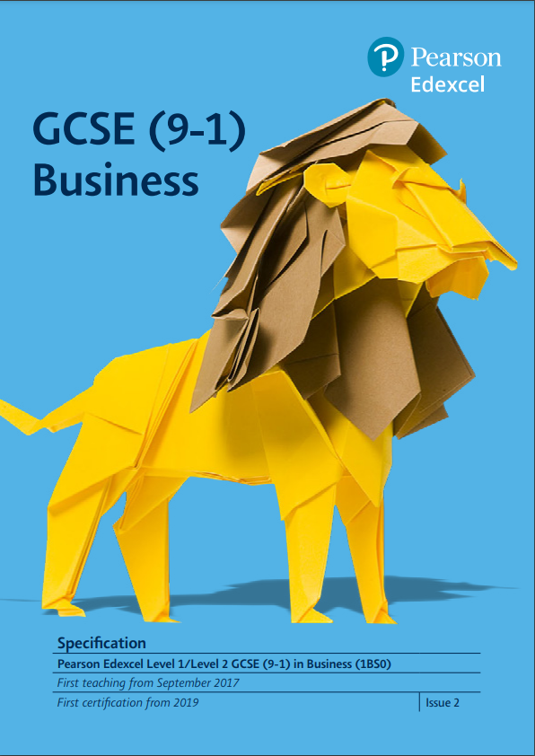

Exam Board
Specification
Pearson Edexcel
GCSE 9-1 Business (from 2017)

Assessment Details
The course is assessed in 2 external exams to be taken in May/June 2026.
Paper 1 – Investigating Small Business – 50% - 1hr 45mins
Paper 2 – Building a Business – 50% - 1hr 45mins
Each paper is broken into 3 sections. Section A will assess core knowledge. Section B and C will assess applied knowledge of Business by providing a case study that must be analysed to inform the extended writing answers that follow.
Final Examinations
Both units are externally assessed in May 2025.
Skills/Aptitudes Required for Success
Independent study skills
Good communication
Good at English and Math
Organisational skills

Staff Contact for Further Information
Mrs K McGloin, Head of Technology

