COURSE CONTENT:
Art, Craft and Design can involve use of an almost limitless range of techniques, processes and materials, including those that are recyclable. A wide range of processes, tools, techniques, materials and resources may be employed to create artefacts and to generate diverse evidence of working methods and outcomes. The emphasis is on an increased breadth of approach commensurate in demand with the depth of learning required in the more specialised titles. Art, Craft and Design can be distinguished from other titles in as much as students are able to explore personal interests and demonstrate their abilities across a particularly broad course of study. Students must also explore practical and relevant critical and contextual sources such as the work of historical and contemporary artists, craftspeople and designers as well as the different purposes, intentions and functions of art, craft and design as appropriate to their own work. Art, Craft and Design offers flexibility in content and approach and students undertaking this option must explore and create work associated with at least two of the titles listed below:
- Fine Art
- Graphic Communication
- Textile Design
- Three-dimensional Design
- Photography
- Critical and Contextual Studies.

Art and Design (Art, Craft and Design)
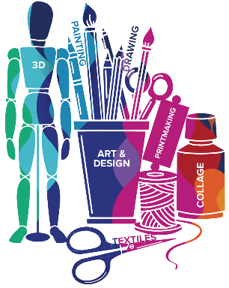

Exam Board
Specification

Component 1 - Portfolio
60% of GCSE 120 Marks
Component 2 - Externally Set Assignment
40% of GCSE 80 Marks
TOTAL MARKS (200)
WJEC Eduqas GCSE in ART AND DESIGN

Assessment Details
- Assessment Objective 1- (Research)
Develop ideas through investigations, demonstrating critical understanding of sources.
- Assessment Objective 2 - (Development of Designs)
Refine work by exploring ideas, selecting and experimenting with appropriate media, materials, techniques and processes.
- Assessment Objective 3 - (Observations, collecting imagery and documenting ideas)
Record ideas, observations and insights relevant to intentions as work progresses.
- Assessment Objective 4 - (Final outcome for the project)
Present a personal and meaningful response that realises intentions and demonstrates understanding of visual language.

Final Examinations
10hour Exam – Where candidates create a final outcome to realise and finalise their response towards the Externally Set Assignment. Exam conditions apply, candidates will be unaided and under supervised conditions from examiners.
Skills/Aptitudes Required for Success
Empathy - Determination - Organisation - Time Management - Creativity - Independence - Confidence - Passion - Desire - Adventurous - Self Critical - Tolerance - Initiative – Communication

Staff Contact for Further Information
Mr Wroe, Teacher of Art
Mrs Simmons, Head of Creative Arts

