GCSE HISTORY
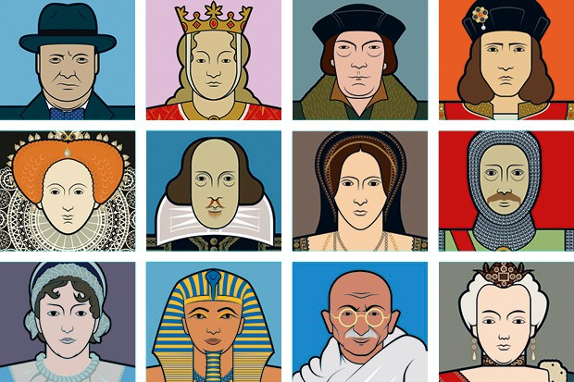
COURSE CONTENT: this is an exciting GCSE History course which enables pupils to learn about the past so that it can shape their future today. Students will study: 1.) in depth the rise of Adolf Hitler and the Nazi party; 2.) the increased international tension after WW1 and how this caused WW2; 3.) the changes in how medicine and public health have developed over time (as a thematic study) whilst also looking closely at 4.) the reign of Queen Elizabeth 1st in Early-Modern England. These areas of study cover a wide range of international and British Historical events which will lead students to ask WHY and HOW events occurred. The course will be packed with discussion and debate supporting pupils with the development of their critical thinking skills.

Exam Board
Specification

AQA
Paper 1: Understanding the Modern World
Paper 2: Shaping the nation

Assessment Details
Students will be assessed by 2 examination papers at the end of the course. Each Paper will be 1 hour 45 minutes in length and worth 50% of the total marks.
Paper 1: Understanding the Modern World will include:
- the period study on Germany 1890-1945: Democracy to Dictatorship; and
- the wider world depth study of Conflict and Tension 1918-1939
Paper 2: Shaping the nation will include:
- the thematic study on Health and the People 1000-present day; and
- the British depth study of Elizabethan England 1568-1603
Skills/Aptitudes Required for Success: History is a highly academic and well-respected subject. It forms part of the English Baccalaureate qualification and supports pupils in their development towards A-Level courses. Students will need to be able to write fluently and be able to give different sides of an argument whilst forming a judgement. Students will need to analyse sources and interpretations to consider how reliable they might be. These are all skills that are learnt throughout the key stage 3 curriculum. Most importantly, students who choose this as a GCSE subject should enjoy studying History and finding out how and why the world we live in today was formed. History is very highly thought of by employers who consider it as one of the most desirable subjects to have studied outside of core subjects. Legal and political career paths are common for those with History qualifications.
Staff Contact for Further Information: Mrs Lee, Head of Department

