BTEC- Tech Award- Construction

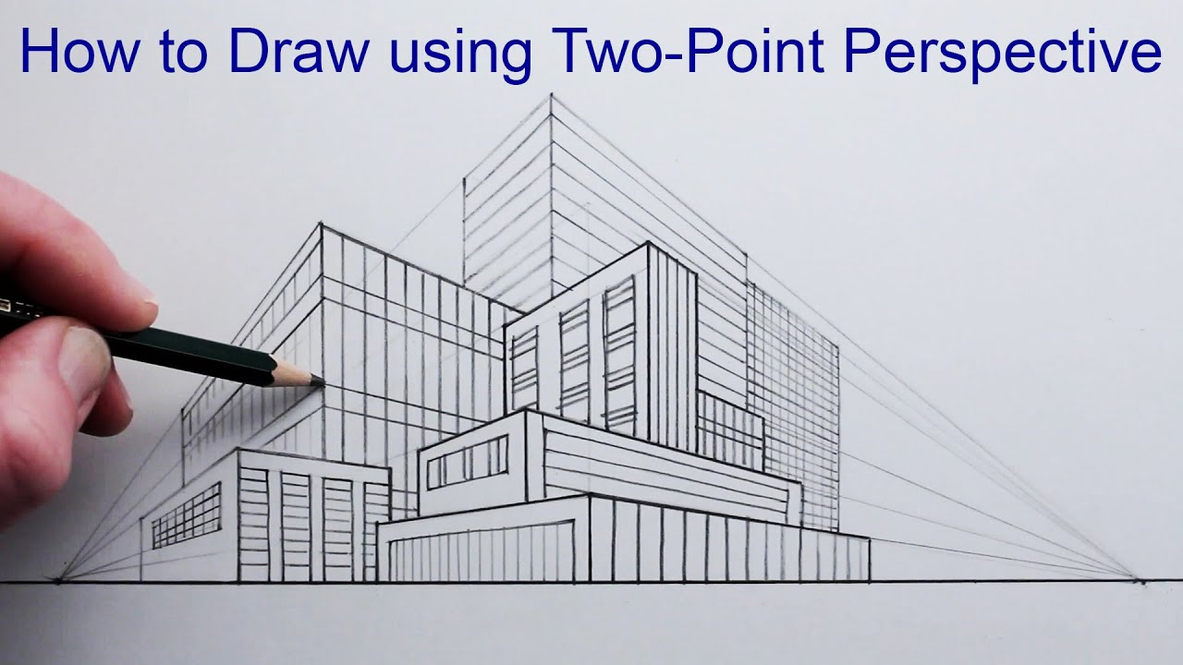



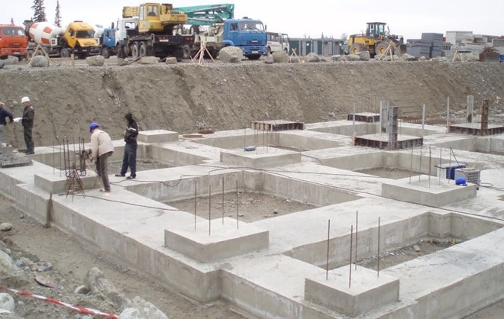

**COURSE CONTENT:** The Tech Award gives learners the opportunity to develop sector-specific applied knowledge and skills through realistic vocational contexts. Learners will have the opportunity to develop applied knowledge and practical skills in the following areas: construction technology, construction in practice and construction and design.

There will also be trip opportunities to visit live construction sites to gain first hand experience.

Exam Board

Specification

Pearson- BTEC

603/7051/8

**Assessment Details (internally assessed, externally moderated)**

Component 2- Construction in Practice – 20 % This unit will include a timed practical exam. You will need to demonstrate your accuracy in measuring and marking, applying skills you have learnt in Math lessons.

You will need to cover the cost of the materials you use, which would roughly be £20. The project is usually completed in year 10, based on a joinery and carpentry assignment given by the exam board. This is the only practical ‘building’ element of the course. You will also develop your knowledge and understanding of safe working practices on a building site, enabling you to write a risk assessment.

Component 3- Construction in Design – 20 % This unit will cover technical drawings: 1- and 2-point perspective, isometric projection and orthographic. You will be given a client brief, which will be analysed and ideas you create from this brief, will be reflected in your concept sketches. This starts in year 10 and is completed in year 11.

**Final Examinations**

Component 1- Exam, worth 60% of the overall BTEC. 60 marks in total. (1 hour and 30 minutes) Theory based on construction information taught in lesson.

**Skills/Aptitudes Required for Success**

You will need to: be organized, self-motivated, critical thinking, problem solver, have good listening skills, communication skills and a developing knowledge of technical skills in the workshop.

**Staff Contact for Further Information**

Mrs L. Bowden, Teacher of Construction