GCSE Physical Education
COURSE CONTENT:
- Applied anatomy and physiology
- Movement analysis
- Physical training
- Use of data
- Sports psychology
- Socio-cultural influences
- Health, fitness and wellbeing

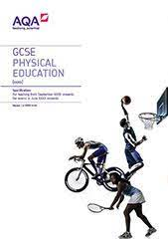

Exam Board
Specification

AQA
GCSE

Assessment Details
Assessed in 3 sports (1/2 team and 1/2 individual) and analysis/evaluation coursework – 40% NEA
Final Examinations
Paper 1: The human body and movement in physical activity and sport
- Written exam: 1 hour 15 minutes
- 78 marks
- 30% of GCSE
Paper 2: Socio-cultural influences and well-being in physical activity and sport
How it's assessed
- Written exam: 1 hour 15 minutes
- 78 marks
- 30% of GCSE
Skills/Aptitudes Required for Success
High level of sporting ability (at least club standard of performance in 2+ sports)
Ability to write well and an extensive vocabulary
High level of interest in Biology and sport in general
Staff Contact for Further Information
Mr Andrews, Head of Department

