CORE: English
COURSE CONTENT:
All students take two GCSEs in English Language (8700) and English Literature (8702).
- Reading a variety of fiction and non-fiction texts
- Inferring, analysing and exploring meanings and ways of creating meaning
- Writing coherent responses with technical accuracy

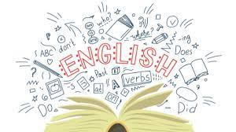

Exam Board
Specification

AQA
8700/8702

Assessment Details
Students are assessed on their ability to read and respond to unseen fiction and non-fiction texts, as well as their ability to communicate ideas and perspectives in their writing. They also study a 19th Century Novel, a Shakespeare play, a modern drama and a poetry anthology as part of the literature qualification, writing essays on these texts.
Final Examinations
English Language:
- 1hr 45m – Reading and Writing Creatively
- 1hr 45m – Writers’ Viewpoints and Perspectives
English Literature:
- 1hr 45m – Shakespeare and the Nineteenth Century Novel
- 2hr 15m – Modern Texts and Poetry
Skills/Aptitudes Required for Success
Reading and responding to texts
Writing with a high degree of accuracy and creativity
Ability to memorise quotations and references from texts
Staff Contact for Further Information
Ms Scanlan, Head of English

