CORE: Combined Science (2 GCSEs)
COURSE CONTENT:
Biology: Cell biology, Organisation, Infection and Response, Bioenergetics, Homeostasis and Response, Inheritance, variation and evolution and Ecology.
Chemistry: Atomic Structure and the Periodic table, Bonding, Structure and the Properties of Matter, Quantitative chemistry, Chemical Changes, Energy Changes, The Rate and Extent of Chemical Change, Organic Chemistry, Chemical Analysis, Chemistry of the Atmosphere and Using Resources.
Physics: Energy, Electricity, Particle Model of Matter, Atomic Structure, Forces, Waves, Magnetism and Electromagnetism.

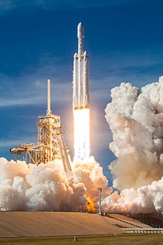

Exam Board
Specification

Combined Science Trilogy (8464)

AQA

Assessment Details
During the course content taught in each unit is assessed in three ways:
- Multiple choice questions
- Formative assessment (1 per unit)
- Summative assessment (1 per unit)
Final Examinations
- 6 exams in total - Each Science (Biology, Chemistry, Physics) has 2 papers
- Each exam is 16.7% of the GCSE
- Each exam is 1hr 15min
- Each exam includes multiple choice, structured, closed, short answer and open response questions.

Skills/Aptitudes Required for Success
- Good Mathematics and Literacy skills are essential
- Good work ethic and the ability to revise from the 1st day of the course
Staff Contact for Further Information
Mrs Rogerson, Head of Department
Ms Poscha, 2nd in Department Mr Swift, Lead Teacher in Science

