CORE: MATHEMATICS
COURSE CONTENT:
- Mathematics is a core subject which is compulsory at GCSE.
- Maths will provide you with a varied and useful ‘toolbox’ of skills with which you can understand a wide variety of mathematical problems.
- It will train you to be logical and systematic and see the relevance and beauty of maths in all areas of life.
- Having a firm grasp of Mathematics is not only key for a career but is also seen as a life skill where employers and colleges will expect a GCSE pass of grade 4 or above to access courses / apprenticeships.

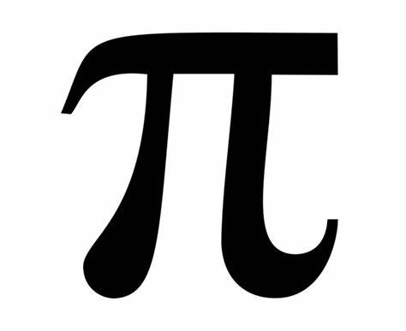

Specification
Exam Board

EDEXCEL
1MA1/1F or 1MA1/1H

Assessment Details
- Pupils will either sit Foundation tier exams or Higher tier exams.
- For each tier there are 3 exams of 1hr 30 mins each.
- First exam is a non-calculator exam and the other two are calculator-based exams.
- Each paper is out of 80 and pupils will get a total mark out of 240 which is converted into a grade.
- It is important that pupils have their own calculator, Casio 83-GTX
Final Examinations
In Mathematics, there are two tiers of entry for the GCSE, Foundation and Higher. The weighting of mathematical content is slightly different at each tier:
Skills/Aptitudes Required for Success
The Edexcel mathematics GCSE will develop and test your knowledge and competency in three ways:
1. Mathematical Fluency – teaching you how to use mathematical skills and procedures on a variety of concepts; from the simple, to the more complex.
2. Problem Solving – teaching you how to approach unfamiliar multi-step questions.
3. Reasoning – teaching you how to communicate effectively and explain using mathematical ideas.

Staff Contact for Further Information

Ms T Khan – Head of Mathematics
Ms D Weldon – KS4 Lead in Mathematics

